**Task 1**

INCLUDE Irvine32.inc

.data

; no data for now

.code

main PROC

mov eax, 4

mov ebx, 5

inc eax

dec ebx

call DumpRegs

; Exit program

invoke ExitProcess, 0

main ENDP

END main

**Pictures of console**

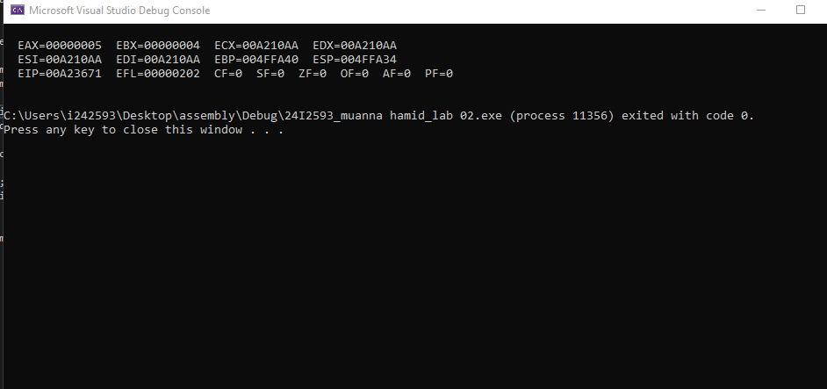

**Picture where values of registers keep changing because of certain operation in the program**

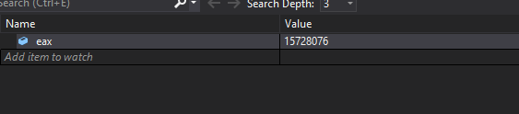

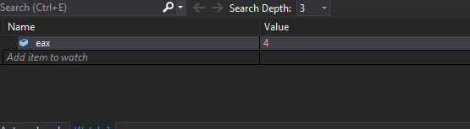

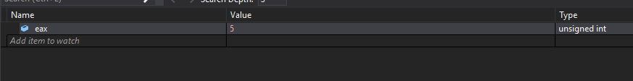

Explanation>>>>>>>>

Code contain only one register eax, so we add that and examine from watch window: to check how and when its value is incrementing and decrementing

**Task 2**

INCLUDE Irvine32.inc

.data

res1 WORD ? ; un initiallied data

res2 WORD ?

res3 DWORD ?

res4 DWORD ?

.code

main PROC

mov ax, 5

mov bx, 3

add ax, bx

mov res1, ax

mov ax, 150h

mov bx, 210h

add ax, bx

mov res2, ax

mov eax, 795

mov ebx, 2388

add eax, ebx

mov res3, eax

mov eax, 4250

mov ebx, 2890

add eax, ebx

mov res4, eax

call DumpRegs

invoke ExitProcess, 0

main ENDP

END main

**Picyures of console**

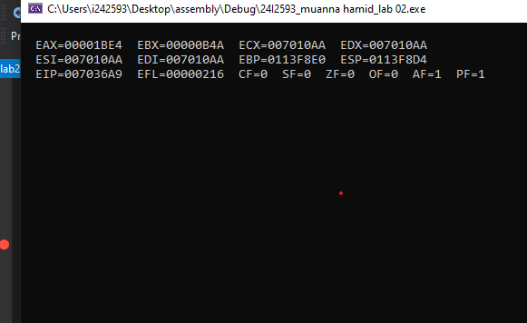

**Picyure where values of registers keep changing because of certain operation in the program** 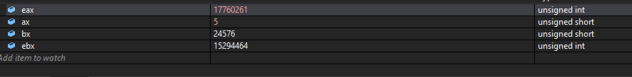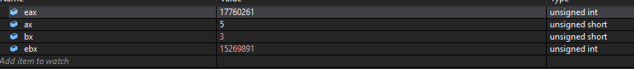

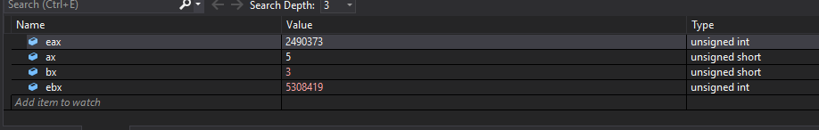

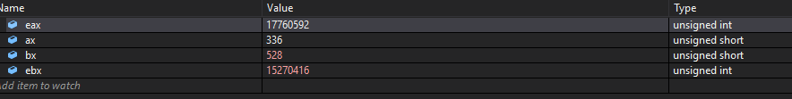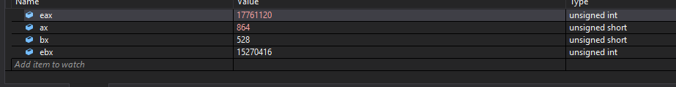

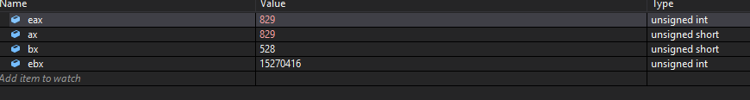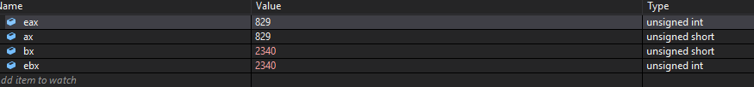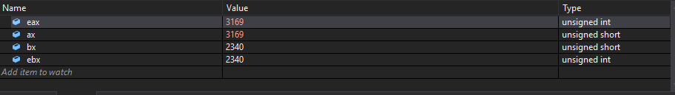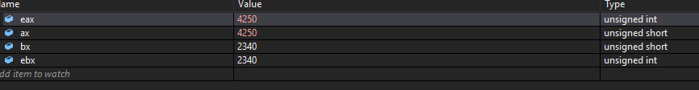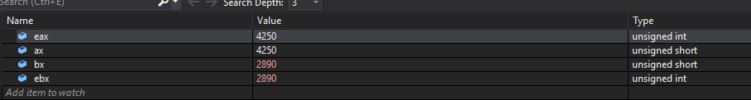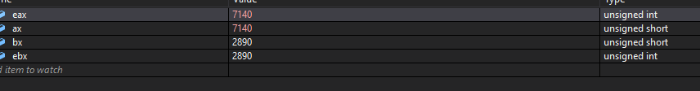

**Picyures where Changing Values of (add)results 1,2,3,4**

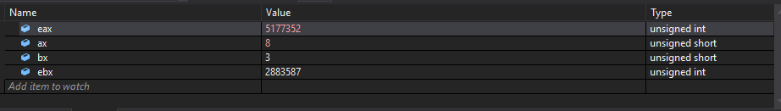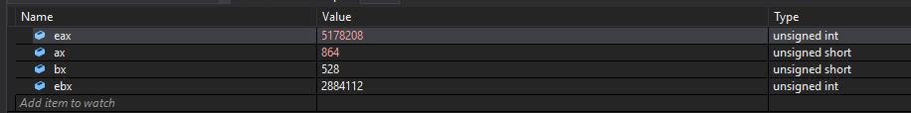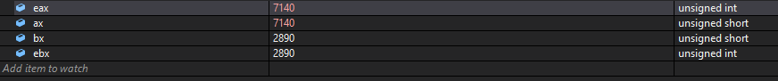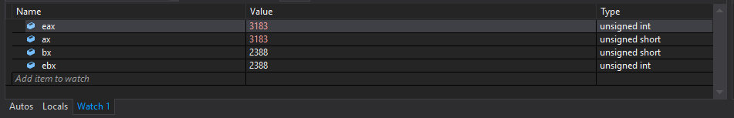

**Task 3**

INCLUDE Irvine32.inc

.data

result1 WORD ?

result2 WORD ?

result3 DWORD ?

result4 DWORD ?

.code

main PROC

mov ax, 40

mov bx, 30

sub ax, bx

mov result1, ax

mov ax, 86

mov bx, 42

sub ax, bx

mov result2, ax

mov eax, 451

mov ebx, 322

sub eax, ebx

mov result3, eax

mov eax, 891

mov ebx, 200

sub eax, ebx

mov result4, eax

call DumpRegs

invoke ExitProcess, 0

main ENDP

END main

**Picyure where values of registers keep changing because of certain operation in the program**

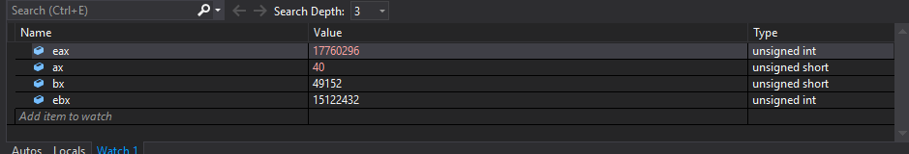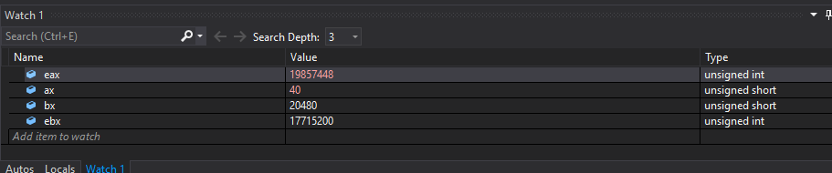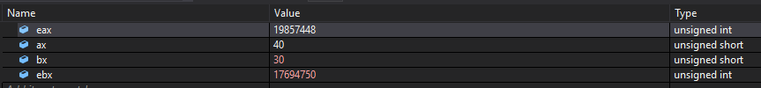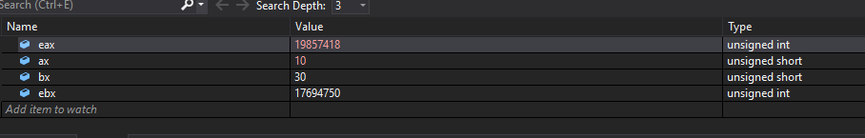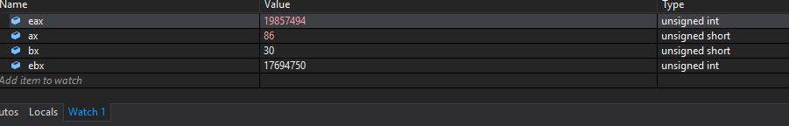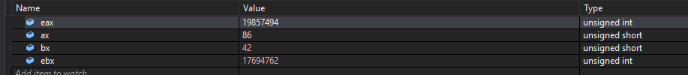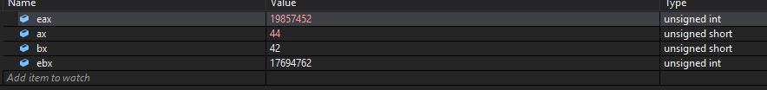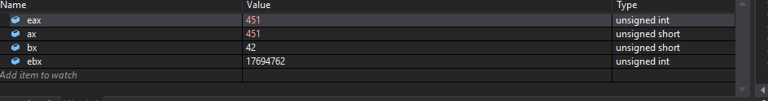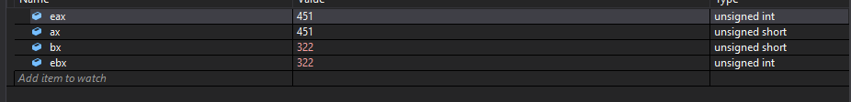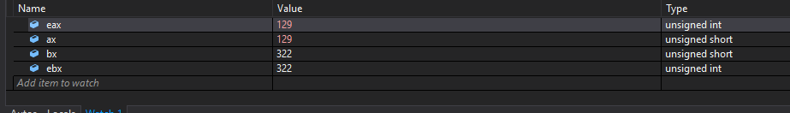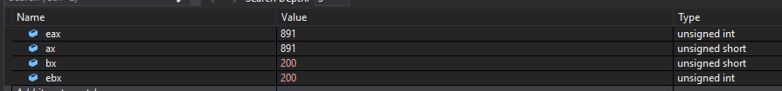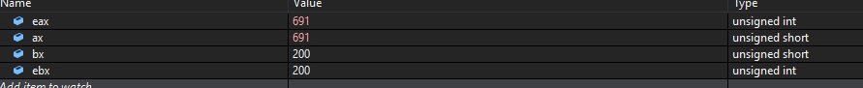

**Pictures of console**

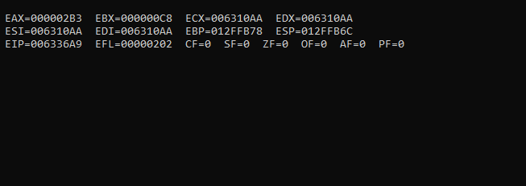

**Task 4**

INCLUDE Irvine32.inc

.data

result WORD ?

.code

main PROC

mov ax, 125

mov bx, 45

mov cx, 40

mov dx, 5

mov ax, 125

mul dx

mov dx, ax

mov ax, bx

mov bx, 4

mul bx

add ax, dx

sub ax, cx

mov result, ax

call DumpRegs

; Exit program

invoke ExitProcess, 0

main ENDP

END main

**Picture where values of registers keep changing because of certain operation in the program**

**“mul”****always multiplies the register AX, with the one that is given.**

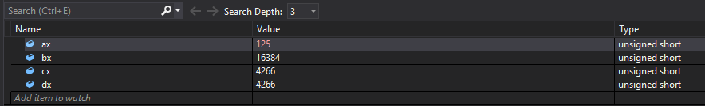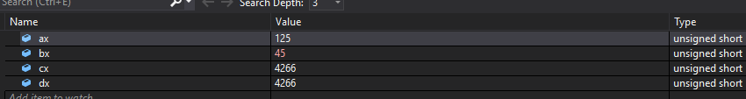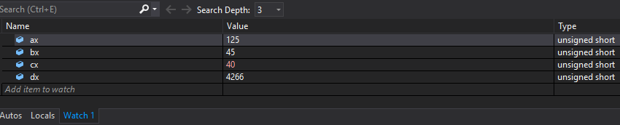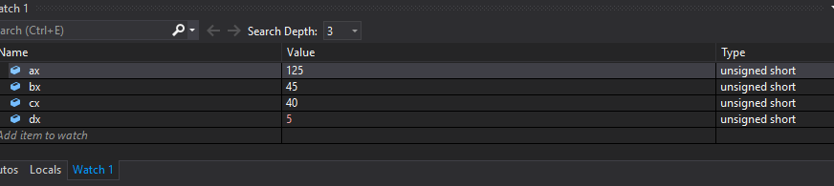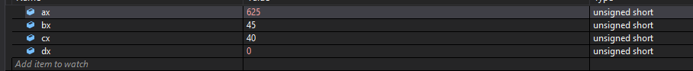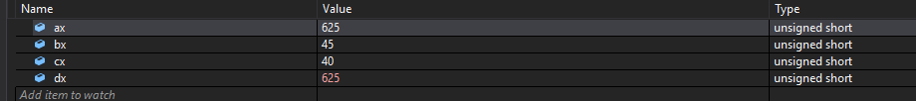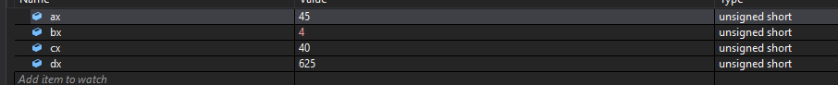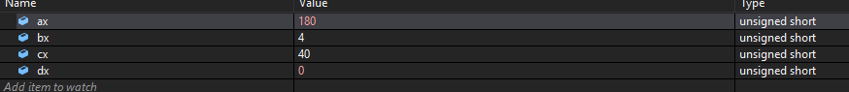

**Picture of console output**

